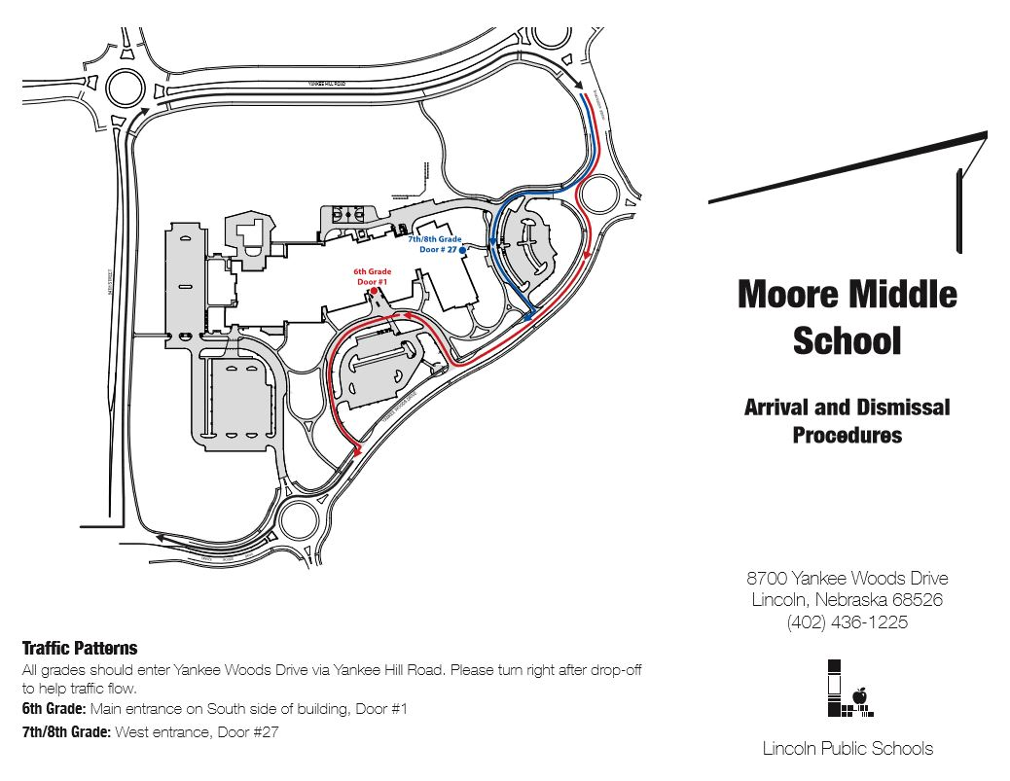

**6th Grade Door #1**

**7th Grade Door #27**

**Traffic Patterns**

**\*RED Route: 6th Grade**

**\*BLUE Route: 7/8 Grade**

All grades should enter Yankee Woods Drive via Yankee Hill Road. Please **TURN RIGHT** after drop-off to help traffic flow.

**6th Grade:** enter building through **DOOR #1**

**7th Grade:** enter building through **DOOR #27**

**8th Grade:** enter building through **DOOR #30**

**8th Grade Door #30**